Nicholas Robertson

Dennis Attawia

CST-105

February 26, 2017

NFL Draft Application Storyboard

Main Page

This is the screen that appears when the application is first opened. The **Enter Draft** button will take the user to the **Player Selection** screen, which will be the central location in which the draft takes place.

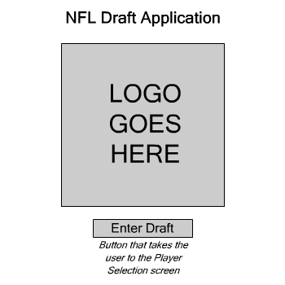

Player Selection

This is the main **Player Selection** screen. The user will be able to view all of the players who have entered the draft, selecting from a list of filters or by searching for the player’s name. The user will be able to draft or remove players from this screen.

The four buttons at the bottom of the screen are as follows:

* **Draft Player**: Adds the selected player to the list of drafted players.
* **Remove Player**: Removes the selected player, if already drafted, from the list of drafted players.
* **Player Card**: Opens a new screen with detailed information about the selected player.
* **End Draft**: Completes the draft and takes the user to the **Team Review** screen.

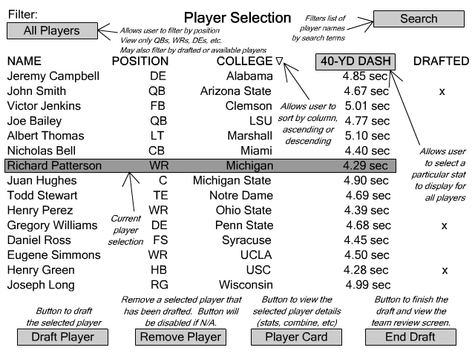

Filter Player

This is the list of available filters that the user can select. The user can filter by the player’s position (quarterback, wide receiver, defensive end, etc.) or their availability (drafted or undrafted).

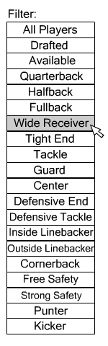

Search Player

The **Search Player** screen will be a pop-up that will allow the user to filter the list of players by entering either the entire name or a partial name. For example, selecting the **Last Name** button and entering a search of “Thom” would display players with last names such as “Thomas” or “Thompson”. The **Clear** button will clear the existing search filter and display all the players in the draft.

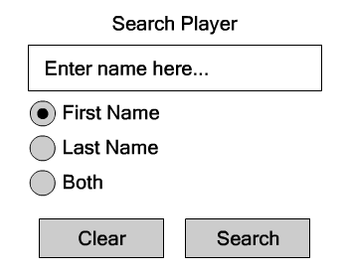

If no results are found, a dialog box will display.

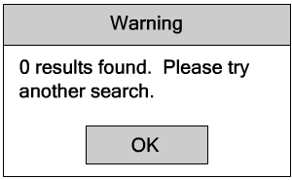

Player Card

The **Player Card** screen is accessed from the **Player Selection** screen by selecting a player and clicking the **Player Card** button. This page will display a detailed description of the selected player, including their height, weight, combine results, college statistics, and the college they attended.

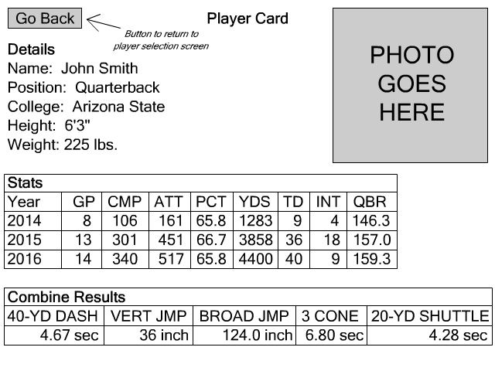

Team Review

The **Team Review** screen provides an overview of the drafted players and when they were taken. The user is able to view the selected player’s card or exit the program.

